

Dr. Cassandra, Brown inc.

2020-06-17

Dr. Brown

732 Hawkins Road, New Mandy, KS 44681

Phone: 3566365264

Fax: 4380005369

**Re:** Aimee, Khan

**PHN:** 6105288035

**Birthdate:** 18-Aug-2003

**Address:** 8178 Steven Knoll, Aaronstad, GA 03418

**Patient number:** 4899358406

To Whom It May Concern:

This is a medical letter to state the above patient is pregnant with expected delivery date of 02-Apr-2025. Hoping this information is satisfactory for your requirements.

Thank you.

Sincerely,

Dr. Cassandra, Brown

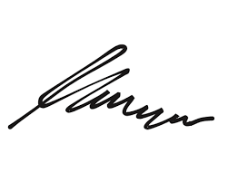

FRCS© NCMP

Clinical Assistant Professor, UBC

Department of Obstetrics and Gynecology SMH